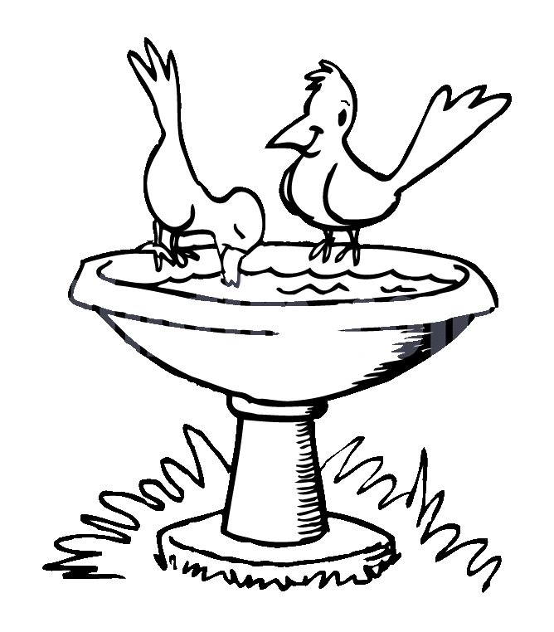**ZAD Global Sr. Sec. School**

**Summer Engagement**

**2019-20**

**Name ……….. … Class 1st Section ………………….**

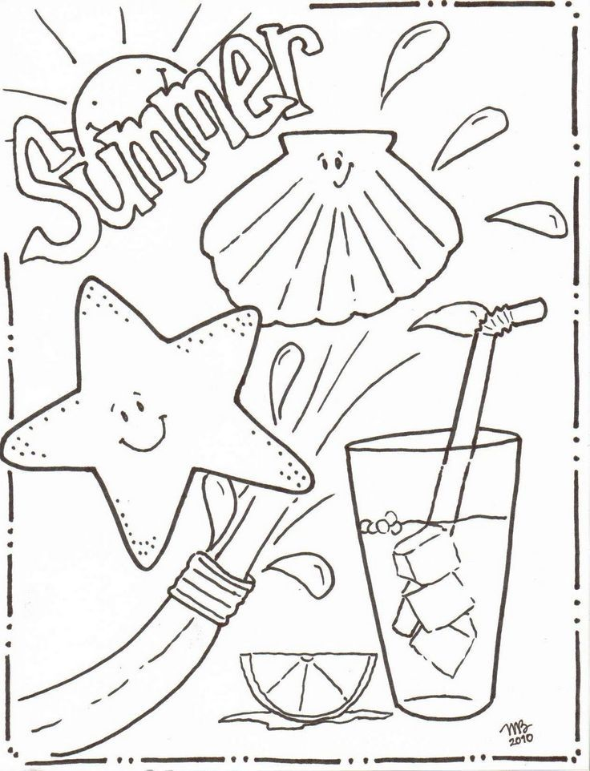

**Colour and Decorate the picture.**

**HAPPY HOLIDAYS!!!!**

**ZAD Global Sr. Sec. School**

**Summer Engagement**

**2019-20**

**Name…………………Class 1st Section ……………………….**

**In our head, we hear a humming,**

**Summer, summer, summer’s are coming**

**Soon we’re all going on a vacation**

**Gearing up with wonderful sensations.**

**Dear parents,**

The much awaited summer vacation is knocking at the door ! The very thoughts of summer break include image of time for relaxation to escape the heat , pursuing of leisure activities and including in good quality time with friends and family . There are plenty of productive ways that your ward can spend the vacation which can be fun relaxing and helpful for his/ her education career.

We wish to imbibe in our students the willingness to spend their summer vacation well .

**Some suggestions in this regard –**

* Practice spoken English at home.
* Encourage your child to read , give him / her some picture book for reading .
* Tell your children to save electricity and water.
* Have at least two meals together with your children. Teach them not to waste their food. Use a napkin and try not make a mess at mealtimes .
* When your child play make-believe they use their imaginations and develop creativity and praise your child when he/ she show their creativity.
* Share stories about your childhood and your family history.
* Be careful of your tone and body language when you talk to a child
* Allow your child to help you at home in household work like watering plants , arranging the dining table , organising his / her cupboard / room and praise him / her for the same.
* Don't give mobile to your child for playing games. Ask them to play outdoor games in evening for indoor games.
* Fix limited time to watch TV that also few particular channels like animal planet , Discovery Channel , Nick Junior etc.
* Make your ward learn and remember his/ her parents mobile/ landline number, house address etc. to make him/ her independent and secure.

**Vocabulary for a day**

Everyday choose a letter and start the day with it like letter -B

In breakfast you can give banana , bread and butter. Go to park and search the things like ball , baby , bench , butterfly , bee etc.

End of the day let him /her count the total words by recalling all the words.

**STAR PERFORMER OF THE HOUSE**

|  |  |  |  |  |  |  |  |
| --- | --- | --- | --- | --- | --- | --- | --- |
|  | MON | TUE | WED | THU | FRI | SAT | SUN |
| I can water plants |  |  |  |  |  |  |  |
| I can help mom |  |  |  |  |  |  |  |
| I love to share |  |  |  |  |  |  |  |
| I can arrange the room |  |  |  |  |  |  |  |

Appreciate them for their efforts.

**Use of Magic words like EXCUSE ME , SORRY , THANKS , PLEASE , MAY I.**

* **When asking for something , say “Please”.**
* **When receiving something , say “ Thank you”.**
* **Don’t interrupt grown- ups who are speaking with each other unless there is an emergency.**
* **If you need to get somebody's attention right away , the phrases “excuse me” is much polite way for you to enter the conversation.**
* **When you have any doubt about doing something ask permission first it can save you from many hours of grief letter .**

**The teachers are trying to encourage the children to use simple words , phrases and sentences like:-**

* **May I go to play?**
* **I have finished work .**
* **Ma’am may I go to the washroom?**
* **Ma’am may I go to the drink water?**
* **Ma’am may I come in please ?**
* **Ma’am may I go to wash my hands ?**
* **Ma’am I want to sit in the front row as I can't see from the back.**
* **Ma’am please repeat the concept as I am unable to understand it.**
* **Ma’am I have lost my shoes / blazer / tiffin box / water bottle etc..**
* **Ma’am I came late as I missed my bus. I am sorry for the delay.**
* **Ma’am , I am sorry , I have forgotten to bring my book , notebook , pencil / eraser drawing book etc.**
* **Ma’am I am sorry I couldn't complete my homework as I was unwell.**
* **Ma’am may I borrow a pencil / eraser / ruler etc. From my partner as I have forgotten to bring it today.**
* **Could you hand me the book.**
* **Could you please shut the door.**

**Children can be encouraged to use simple words and sentences at home also. For example-**

* **Mummy , can I help you in the kitchen.**
* **Mummy , can I lay the table today.**
* **Mummy , should I help you wash the dishes today.**
* **Papa, can I help you wash the car.**
* **Grandpa, should I come with you for a walk.**
* **Mummy can I get you glass of water.**
* **Mummy , may I take some more Ice - Cream for the fridge?**
* **Papa , I'm sorry I was rude to you.**
* **Papa , please teach me how to ride a bicycle.**
* **Didi , can you help me find my English notebook.**
* **Papa , can we go cycling together today.**
* **Wishing people properly- Hello Uncle / Aunty , How are you ?**
* **Wishing parents and elders Good morning , Good Afternoon , Good Evening and Good Night. If we as teachers and parents make a sincere effort and pay attention to the above mentioned points , we can help our children to learn to understand and speak English at an early age .**
* **The School has also devised some summer holiday homework that is linked to the curriculum and is also creative to monitor the progress of your ward.**
* **Please assist rather than take over , this would help in enhancing the child’s creative skills.**

**Note: Summer break will commence from ….. May 2019 and the school will reopen on 4th July 2019(Thursday).**

**Submit the holidays homework in a folder by 8th July 2019**

**English**

**Note : Do no. 1 , 2 work on Pink colour A4 sheet.**

1. **Look at the Letter ,maze and write the names of six fruit s , six vegetables , six animals .**

|  |  |  |  |  |  |  |  |  |  |  |  |  |  |  |  |
| --- | --- | --- | --- | --- | --- | --- | --- | --- | --- | --- | --- | --- | --- | --- | --- |
| **B** | **R** | **I** | **N** | **J** | **A** | **L** | **O** | **N** | **D** | **O** | **N** | **K** | **E** | **Y** | **G** |
| **C** | **A** | **R** | **R** | **O** | **C** | **A** | **T** | **I** | **H** | **O** | **R** | **S** | **E** | **Z** | **R** |
| **A** | **M** | **C** | **A** | **W** | **A** | **C** | **A** | **C** | **A** | **R** | **R** | **O** | **T** | **W** | **A** |
| **T** | **O** | **A** | **D** | **Y** | **M** | **L** | **P** | **O** | **T** | **A** | **T** | **O** | **P** | **P** | **P** |
| **S** | **N** | **T** | **I** | **G** | **E** | **R** | **P** | **B** | **A** | **N** | **A** | **N** | **A** | **I** | **E** |
| **I** | **K** | **U** | **S** | **X** | **L** | **Y** | **L** | **Z** | **Z** | **G** | **U** | **A** | **V** | **A** | **S** |
| **C** | **E** | **R** | **H** | **A** | **B** | **C** | **E** | **E** | **L** | **E** | **P** | **H** | **A** | **N** | **T** |
| **U** | **Y** | **N** | **E** | **C** | **O** | **W** | **L** | **B** | **C** | **D** | **E** | **E** | **R** | **L** | **O** |
| **M** | **S** | **I** | **E** | **A** | **Z** | **X** | **I** | **R** | **A** | **F** | **O** | **N** | **I** | **O** | **N** |
| **O** | **H** | **P** | **P** | **D** | **O** | **G** | **O** | **A** | **T** | **O** | **M** | **A** | **T** | **O** | **N** |
| **X** | **P** | **E** | **A** | **R** | **M** | **A** | **N** | **G** | **O** | **X** | **B** | **E** | **A** | **R** | **H** |

|  |  |  |
| --- | --- | --- |
| **Fruits** | **Vegetables** | **Animals** |

1. **Make words from following sound and write sentences with them.**

**y is**

**at at**

**Wh en Th ey**

**o ese**

**ich ose**

1. **Draw or paste the pictures of ‘ Ball ‘ and ‘Table ‘ and write 5 lines on each in class N.B.**
2. **Learn Poem ‘Mary Had a Little Mouse’ from Literature book on pg no. 23.**
3. **Do Practice of reading daily.**
4. **Revise the Term -1 syllabus done in class till date .**

**Hindi**

1. **“ सुनहरी धूप “ पाठ्य पुस्तक में पृष्ठ संख्या 42 , 43,को पूरा करें तथा पृष्ठ संख्या 117 , 118 पर दी गई कविताओं को याद करें |**
2. **“ हिंदी व्याकरण” अभ्यास पुस्तिका में पृष्ठ संख्या 26, 27, ,31,51 को पूरा करें |**
3. **अपने कमरे का निरीक्षण करें तथा उन वस्तुओं जिनके नाम में “आ , इ , ई , उ , ऊ” की मात्रा आती है उनके चित्र Yellow A4 Sheet ij चिपकाए व नाम लिखें |**
4. **Yellow A4 Sheet ij 5-5 पशु- पक्षियों , फलों , वस्तुओं , व्यक्तियों , जगहों व फूलों के चित्र चिपकाए व नाम लिखें |**
5. **अपनी मां की सहायता से नींबू , चीनी व पानी का प्रयोग करके शिकंजी बनाना , कमीज के बटन बंद करना , कंघी करना व जूतों के फीते बांधना सीखें**
6. **पाठ्य पुस्तक व हिंदी व्याकरण का अभ्यास पुस्तिका में SA -1 के अब तक करवाए गए पाठ्यक्रम की दौहjkई करें**

**Maths**

**Note:- Do the given work on the Sky blue colour A4 sheet.**

1. **Learn and Write tables of 0 to 5 , 2 times.**
2. **Do 10-10 sums of addition and subtraction.**
3. **Draw or paste the animals in ascending order according to the size example- elephant , rat , cat , giraffe , cow , goat etc.**
4. **Draw or paste the fruits in descending order according to the size example- watermelon , mango, grapes , litchi etc.**
5. **Make a robot by using different shapes on A4 sheet and decorate it.**
6. **Do pg 36 to 38, 41 , 44 to 49 , 132 , 133 in book.**

**EVS**

**Note:- Do the given work on the Green colour A4 sheet.**

1. **Read Ch- 6,7 thoroughly.**
2. **Learn syllabus of term-2 done till now.**
3. **Do pg- 43, 47, 52 in book.**

**Activities:**

* **Make flash cards of food products which we get from animals**
* **Draw a fruit basket , draw and colour the fruits of Summer Seasons in the basket.**
* **Write any five healthy food habits with pictures**
* **Make a beautiful greeting card for father's day also Paste a photograph along with you.**
* **Make any one model using waste material. First aid box / Traffic lights ( Refer pg-28)**

**G.K : Paste the National Symbol on the White A4 Sheet.**

**I.T: Paste the parts of computer on the Light Purple A4 Sheet**

**Art : Do Pg-16,17,8 , 9 , 10 Craft :Book Marker**